### MILESTONE 3: A mid-point progress review (with second assessor) 20% - document between 5000-6500 words + 30 minutes Presentation

[MILESTONE 3: A mid-point progress review (with second assessor) 20% - document between 5000-6500 words + 30 minutes Presentation](https://blackboard.staffs.ac.uk/webapps/blackboard/content/listContent.jsp?course_id=_68451_1&content_id=_4050342_1&mode=reset)

 A mid-point progress review (with second assessor) 20% - document between 5000-6500 words + 30 minutes Presentation  
  
Your mark for the MPR is worth 20% of your overall dissertation mark.  
  
Your Second assessor will enter your marks onto Blackboard using the MPR rubric and provide you with feedback.  
  
**Your Report should contain the following**

|  |  |  |
| --- | --- | --- |
|  |  | weight |
| Abstract - 100 - 200 words |  | 5% |
| (use the content from the attached proposal) |  |  |
| Introduction incl. motivation, aims, objectives and objetives - 500 - 800 words words |  | 10% |
| (use the content from the attached proposal) |  |  |
| literature review - 3500 - 4000 words  (to be done) |  | 40% |
| research gap - 300 - 500 words  (to be done) |  | 15% |
| Initial artefact progress - 300 - 500 words  (to be done) |  | 10% |
| Future plan - 300 - 500 words |  | 10% |
| (to be done) |  |  |
|  |  |  |
| **The max word should be around 5000-6500 word.** |  |  |

**30Min Presentation:**

|  |  |  |
| --- | --- | --- |
|  |  | weight |
| Presentation/enthusiasm |  | 10% |

Table of Contents

Introduction/Synopsis (to Proposal) 3

Research Question 5

Aim 5

Objectives 6

Deliverables 6

Academic Challenge 7

Plan of Work (Timescale or project plan) 8

Resources 8

Reference List 9

# **Introduction**

The growth of information technology has significantly altered the way financial markets operate (Kissell, 2021). Trading system automation in financial markets is the final stage of de-personalizing activities traditionally performed by traders(Schmidt et al., 2010). Whilst Computers still do not make their own decisions about which instruments for trading or what trading criteria to use (Velu et al., 2020). Research has shown that they were able to determine when and how to execute trade orders based on the traders' parameters thanks to automated trading advancement (Manahov et al., 2015). They put the trader's approach into action by helping pick an appropriate time to complete an action (Schmidt et al., 2010). Computer based trading also has advantage for high-frequency trading, which allows for the fast execution of algorithmic processes(Kissell, 2021). The purpose of this research is to explore, via a produced novel algorithmic tool, how computer-based trading can help to negate the issues caused by the emotional state of traditional human traders, with the overall objective of increasing revenue and overall profits from high frequency trading. This tool is novel because it makes profit from the market consistently, because it can adapt to changing market conditions and it follows the current market trends, for as long as market moves the system can make profit.

**Research Background (problem or improvement area)**

There have been attempts to study how algorithmic trading could be the way out for emotional impacted traders.Algorithmic trading has gained popularity among both retail and institutional traders in the twenty-first century(El-Yaniv et al., 2001). Investors and traders can create automated trading systems that allow computers to execute and monitor deals based on defined entry, exit, and money management rules (Manahov et al., 2015). One of the most appealing aspects of automation is that it removes emotion from trading by automatically placing trades when certain conditions are met(Beason &Wahal, 2019).Typically, automated trading systems require software that is tied to a direct access broker, and any special rules must be developed in the platform's proprietary language. Simple to use mql5 programming language for Metatrader 4 (MT4) or aMetatrader 5(MT5) platform. MT4 or MT5 isa kind of software that primarily focuses on forex markets and is uniquely made for forex traders (El-Yaniv et al., 2001). Mql5 is MetaQutes language 5 is an unique high level object oriented programing language that permits users to create trading robots and technical indicators (Aloud &Fasli, 2016).

During the trading process, automated trading systems reduce the impact of emotions resulting from fear and greed of traders (Zucchi, 2021). Traders would not need to intervene with algorithmic trades because trades are executed automatically once the trade rules are met. Automated trading can help traders who are reluctant to "pull the trigger," as well as those who are prone to overtrading or buying and selling at every opportune moment (Yuferova, 2015).

Backtesting is another advantage of algorithmic trading (Velu et al., 2020). Backtesting enables a trader to obtain outcomes and measure profitability without risking any real money by simulating a trading strategy using past data. A successful backtest convinces traders that the strategy is fundamentally sound and will likely produce profits when executed in the real environment or live account (Velu et al., 2020). A well-conducted backtest that provides unsatisfactory results, on the other hand, will cause traders to change or reject the automated traditional strategy (Velu et al., 2020).

With automation getting in and out of a trade can happen within few seconds significantly impacting the result of the trade (Yuferova, 2015). All additional orders, including protective stop losses and profit targets, are automatically placed after a position is registered as a market or pending order (Yuferova, 2015). Markets move quickly, and it can be discouraging to see a trade hit its profit target or blast over a stop-loss level before the orders are even placed. This is avoidable by using an automated trading system (Aloud &Fasli, 2016).

As a result of the identification of these issues, the researcher proposes to investigate how emotions could be removed altogether from trading through the automation of traditional trading strategies. The proposed trading program is a novel combination of indicators programmed to execute trades when certain parameters for buy or sell signals are met (Casgrain&Jaimungal, 2018). The program, in backtest and forward test, will be able to generate profits at a speed and frequency that is impossible for a human trader(Velu et al., 2020). Back testing the program is experimenting profitability of the program using historical data, while forward testing referred to evaluating profitability performance using current data. Algorithmic trading is also referred to as automated trading systems(Bouchard et al., 2011).

# **Research Questions**

# Question 1 – Do human emotions have a negative impact on profitability of their trades in forex market?

# Question 2 – Has the automation of trading had an effect on profitability of trades?

# Question 3 – How effective are currently existing automation solutions at tackling the problem of profit loss due to human emotional states?

# Question 4 – Can this process be improved by the development of a novel trading algorithm?

# **Aim**

# The aim of this research will be:

# To develop a novel algorithmic solution for automated trading within forex market, a 3 trillion market using the mql5 programming language.

# **Objectives**

* Synopsis of this research objectives are:
* 1 – To investigate whether the emotional state of traders has been identified as a problem within the financial sector.
* 2 – To investigate current solutions and developments in the use of algorithmic trading programs
* 3 – To investigate the effectiveness of those solutions.
* 4 – To develop a new solution based on the MQL5 programming language which can be used to combat the impact of human emotional states on trading profitability
* 5 – To investigate the effectiveness of the newly proposed solution.

# **Deliverables**

The project deliverables for this project is

* A working algorithm that can simulate forex trading scenarios and see how our developed algorithm can help the emotions of a trader who may experience mixed emotions during trading.
* A comprehensive report will also be delivered. The report will feature all the data analysis, findings, and challenges encountered and how efficiently the software has effectively managed trades to ensure consistent profitable trades.
* Report in the form of a Literature Review which will evidence the need for this novel automated solution.

# **Academic Challenge**

Just like any other research project, there are challenges that one can experience include:

* Little to no mql5 coding knowledge or skill is a limiting factor which could introduce bugs in the the trading program, this challenge I will tackle by taking special mql5 programming courses and testing the program rigorously to ensure not bugs are in the codes.
* System crashes during backtesting and forward testing of the algorithmic system could result in inaccurate data analysis. This challenge is intented to be managed through the use of virtual computers (VPS).
* The time frame may also be a challenge.

# **Plan of Work (Timescale or project plan)**

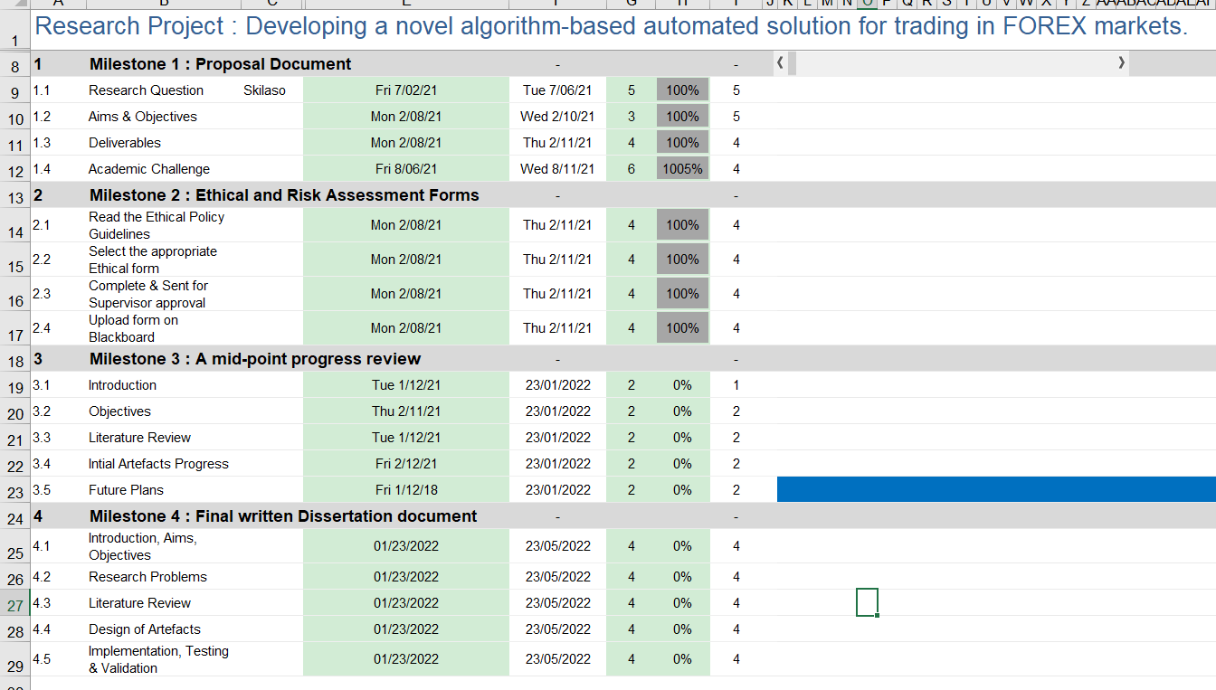

# **Resources**

|  |  |
| --- | --- |
| **No** | **Resource** |
|  | Database program |
|  | Hardware |
|  | Internet |
|  | Custom made technical indicators used for automation |
|  | Mql5 program |
|  | Other costs and expenses |

**Literature Review**

According to Driver (2013) in his book entitled, in introduction to Forex trading highlights a number factors that are considerable in highlighting successful trading within the Forex Market. According to the author, pip is a term that is frequently used to describe the moving market differences in the in the profit and loss of a currency, in the Forex Market, brokers are usually involved in the trading of currencies within the Forex ecosystem, however, it’s the sole duty of the of the individuals to understand the markets before conducting the trades.

Leverage is a term that is used frequently in the trading market to examine the potential gain that an individual stands to gain suppose they decide to trade in the markets, the leverage can be the smaller amount applied to as a smaller instruments of trade but the benefits that arise from the leverage can either be higher or low depending on how correctly the individual might have predicted the market. In a case where the individual might have predicted the market correctly, then the leverage is multiplied by the potential possible sell value. Further, this study discusses the homework that one needs to do before indulging in the purchase or sell of the Forex trade and this kind of analyses relies on majorly three kinds of analysis that include:

* Fundamental analyses
* Technical analyses
* Market sentiments

Fundamental analyses is based on the news that informs the current status and economic well-being of the country. The better the news and information being dispersed by the media, the stronger the economy. People will react based on the news and information that is fed to them either from mainstream media like the TVs, Newspapers and radios and also from social media platforms like Twitter, Facebook or Instagram. Such news can revolve around factors like employment rates, retailing price of goods and items, the political, stability of a nation and then the inflation reports. Ideally, if the above factors are doing well, then the country is also considered to be doing well and so its dollar currency value considered as stronger. Technical analyses on the other involve the digital analyses of the datasets obtained from trade centres and then used to calculate and predicate the market scenarios, based on when to buy or sell a financial instruments. These factors then form the basis of the direction that the market will take and such can tell whether it will be up or down.

In another article written by Guides (2018), indicate the significance value that crypto currencies play in the overall understanding and the evaluation of the Forex trading system. Monero as such one crypto currency has been built for privacy with the main aims and objectives of preserving the anonymity of users transacting on the network. Monero just like Bitcoin does this by hiding the user specific details related to the transactional amounts and the type of transactions that are being carried.

Further, his study highlights the role that crypto currency has played in the efficient transaction and transactions on the Forex trading ecosystem. In a fast paced and technically oriented market place, crypto currency has dominated the top most preferred trading asset among other currencies, according to this review, Monero was the 11th most preferred crypto and also trades fairly well in the markets.

Deep learning and machine learning too have a role to play in determination of perfect stock trading. According to Usha et al (2019), data can be collected over a specified period of time and trained to help measure and predict the FOREX market situation. This process involves choosing the correct dataset from the intended market domain, splitting the dataset into A and B to typically mean training and test data respectively, usually, the training set is set at a higher value than the test data, also known as AB testing, in which the 80/20 rule is applied.

The final intention and objective is to get the most accurate prediction from the situation. The study also outlines that correct deep leaning algorithms depends on studying the historical nature and performances of such datasets, and monitoring their performances overtime, for instance, a historical analyses could reveal how certain market currencies performed overtime and then these realisations could be used to estimate the future directions of a particular market condition. In such an instance, deep learning has been so effective in understanding the correlation between datasets and predictive analytics can further be used to analyse direction that the stock market will take. This study also reveals that deep learning can show hidden patterns and behaviours that can be exploited by individuals and analysed for understanding the market segments, flow of currencies buys and sells regardless of the prevailing market conditions at the time.

‘

# **Reference List**

Aloud, M., &Fasli, M. (2016). Exploring trading strategies and their effects in the foreign exchange market. *Computational Intelligence*, *33*(2), 280-307. <https://doi.org/10.1111/coin.12085>

Beason, T., &Wahal, S. (2019). The anatomy of trading algorithms. *SSRN Electronic Journal*. <https://doi.org/10.2139/ssrn.3497001>

Bouchard, B., Dang, N., &Lehalle, C. (2011). Optimal control of trading algorithms: A general impulse control approach. *SIAM Journal on Financial Mathematics*, *2*(1), 404-438. <https://doi.org/10.1137/090777293>

Casgrain, P., &Jaimungal, S. (2018). Trading algorithms with learning in latent Alpha models. *Mathematical Finance*, *29*(3), 735-772. <https://doi.org/10.1111/mafi.12194>

DeMarzo, P., Kremer, I., & Mansour, Y. (2006). Online trading algorithms and robust option pricing. *Proceedings of the thirty-eighth annual ACM symposium on Theory of computing - STOC '06*. <https://doi.org/10.1145/1132516.1132586>

El-Yaniv, R., Fiat, A., Karp, R. M., & Turpin, G. (2001). Optimal search and one-way trading online algorithms. *Algorithmica*, *30*(1), 101-139. <https://doi.org/10.1007/s00453-001-0003-0>

Estimating algorithmic execution tools. (2013). *Professional Automated Trading*, 237-243. <https://doi.org/10.1002/9781118755846.ch17>

Forex trading using Intermarket analysis. (2015). *Intermarket Trading Strategies*, 261-292. <https://doi.org/10.1002/9781119207153.ch17>

Kissell, R. (2014). Portfolio algorithms. *The Science of Algorithmic Trading and Portfolio Management*, 297-329. <https://doi.org/10.1016/b978-0-12-401689-7.00009-x>

Kissell, R. L. (2021). Algorithmic trading. *Algorithmic Trading Methods*, 23-56. <https://doi.org/10.1016/b978-0-12-815630-8.00002-8>

Manahov, V., Hudson, R., & Hoque, H. (2015). Return predictability and the 'wisdom of crowds': Genetic programming trading algorithms, the marginal trader hypothesis, and the Hayek hypothesis. *Journal of International Financial Markets, Institutions, and Money*, *37*, 85-98. <https://doi.org/10.1016/j.intfin.2015.02.009>

Schmidt, G., Mohr, E., &Kersch, M. (2010). Experimental analysis of an online trading algorithm. *Electronic Notes in Discrete Mathematics*, *36*, 519-526. <https://doi.org/10.1016/j.endm.2010.05.066>

Spindler, G. (2020). Control of algorithms in financial markets. *Algorithms and Law*, 207-220. <https://doi.org/10.1017/9781108347846.008>

Torres, E. P., Torres, E. A., Hernandez-Alvarez, M., &Yoo, S. G. (2020). Emotion recognition related to stock trading using machine learning algorithms with feature selection. *IEEE Access*, *8*, 199719-199732. <https://doi.org/10.1109/access.2020.3035539>

Undefined. (2017). *Machine Trading*, 1-25. <https://doi.org/10.1002/9781119244066.ch1>

Velu, R., Hardy, M., &Nehren, D. (2020). Algorithmic trading and quantitative strategies. *Algorithmic Trading and Quantitative Strategies*, 383-400. <https://doi.org/10.1201/9780429183942-11>

Zucchi K. How to avoid Emotional Investing, <https://www.investopedia.com/articles/basics/10/how-to-avoid-emotional-investing.asp> (Assessed 25 . 11 . 2021)

Driver, M. (2013). *An Introduction to Forex Trading-A Guide for Beginners*. Matthew Driver.

Guides, T. S. (2018). Monero Trading for Beginners–The world’s biggest privacy coin.

Usha, B. A., Manjunath, T. N., & Mudunuri, T. (2019, March). Commodity and Forex trade automation using Deep Reinforcement Learning. In *2019 1st International Conference on Advanced Technologies in Intelligent Control, Environment, Computing & Communication Engineering (ICATIECE)* (pp. 27-31). IEEE.